Cosmos College of Management and Technology

(Affiliated To Pokhara University)

Subject: Instrumentation

Tutorial: 1

1. Temperature was measured in eight locations in a room, and the values Obtained were 28.2, 16.5, 32.1, 29.7, 27.1, 19.0, 22.0 and 10.0 oC. Assuming That the random errors are present. Calculate (i) Arithmetic mean (ii) Standard Deviation (iii) Probable error of readings
2. What are the applications of Wein Bridge? Derive the necessary expression under balance Condition?
3. A 1000 Hz bridge has the following constants: arm AB, R = 1000 Ω in parallel with C = 0.5 μF; BC, R = 1000 Ω in series with C = 0.5 μF; CD, L = 30 mH in series with R = 200 Ω. Find the constants of arm DA to balance the bridge. Express the result as a Pure R in series with pure C or L and also as a pure R in parallel with a pure C or L?
4. The measurements of the resistance of a resistor are 101.2, 101.7, 101.3, 101.0, 101.5, 101.3, 101.2, 101.4, 101.3 and 101.1. Assume that only random errors are present, calculate (a) Arithmetic mean (b) Average deviation from mean (c) The Standard Deviation and (d) Probable Error.
5. A circuit was tuned by ten different students, and the values of resonant frequency in KHz were recorded as 525, 526, 524, 527, 523, 527, 525, 524, 528 and 527. Assume that only random errors are present. Calculate:

(i) arithmetic mean (ii) average deviation from mean

(iii) standard deviation and (iv) probable error

1. The impedance of the basic ac bridge given below are as: 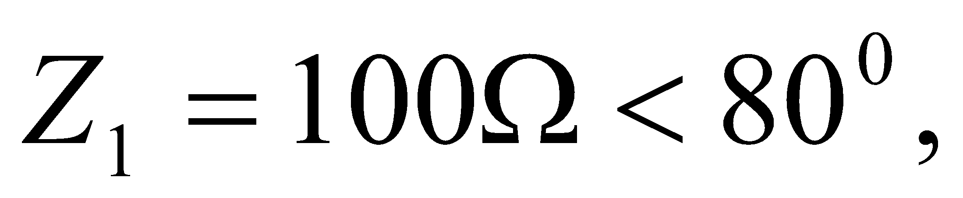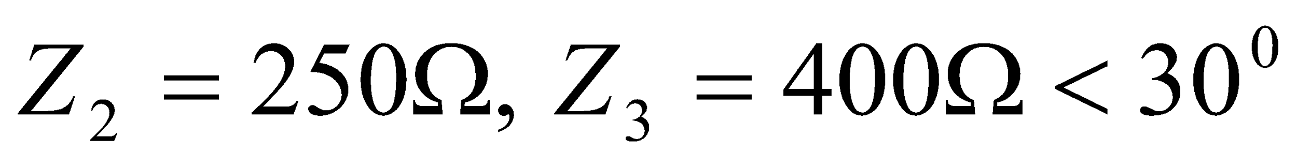. Find the value of Z4, name the unknown component and its value.
2. The A.C. bridge is in balance with the following constant: arm AB, R=450; arm BC, R=300 in series with C=0.047F; arm CD, unknown; arm DA, R=200 in series with L=15.9 mH. The oscillator frequency is 1 KHz. Find the constants of arm CD.
3. It is desired to measure the voltage across the 50K resistor in the circuit shown below. Two voltmeters are available for this measurement: voltmeter 1 with a sensitivity of 1000/V and voltmeters 2 with sensitivity of 20000/V. Both meters are used on their 50-V range. Calculate (a) the reading of each meter. (b) the error in each reading, expressed as a percentage of the true value.

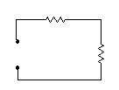

1. An AC bridge has the following constant arms AB, R=1000Ω in parallel with C = 0.159µF; BC, R = 1000Ω; CD, R = 500Ω; DA, C = 0.636µF in series with an unknown resistance. Find the frequency for which this bridge is in balance and determine the value of resistance in arm DA to produce this balance
2. The resistance of an unknown resistor is determined by the Wheatstone bridge method. The solution for the unknown resistance is stated as RX = (R1 R2) / R3, where;

R1 = 500 Ω ± 1 %

R2 = 615 Ω ± 1 %

R3 = 100 Ω ± 0.5 %

Calculate:

(i) the nominal value of the unknown resistor

(ii) the limiting error in ohms of the unknown resistor

(iii) the limiting error in percent of the unknown resistor

1. The four arms of a Maxwell’s bridge at balance are: arm ab – an unknown inductance L1 having an inherent resistance R1; arm bc – a non-inductive resistance of 1000 Ω; arm cd – a capacitor of 0.5 μF in parallel with a resistance of 1500 Ω; arm da – a resistance of 200 Ω. Find the value of unknowns.
2. You are required to measure the weight by using the piezoelectric crystal. Draw the block diagram of additional components and briefly explain about it.